

**Dynamic Car Information**

Final Year Project

Project Proposal

Sean O’Shaughnessy

G0035883

BEng(H) in Software & Electronic Engineering

Galway-Mayo Institute of Technology

2020/2021

**Project Description:**

Important information will be gathered from a car’s Electronic Control Unit (ECU) to allow the user to monitor their car from the comfort of the driver’s seat or their home. This is more aimed to performance cars that have turbo charged engines as the tolerance for error is little to none. Oil Pressure, oil temperature and water temperature are some of the important aspects that would need to be monitored in a car.

The OBD (On-Board Diagnostic) port would be used to access the ECU and using the correct protocol that the car supports the data will be monitored and stored in real-time. I would then use the cloud to store the data that is retrieved from the ECU of the car as this would allow the user to access it from anywhere that you have internet connection. An android application will allow the user to view the live data that is recorded.

The challenges that I believe I will face in this project is getting the server and database to sync with the user interface in real time and using the data from the car in an effective way. I also want to incorporate other features into an app that allows the user to access the data that comes from the ECU of the car.

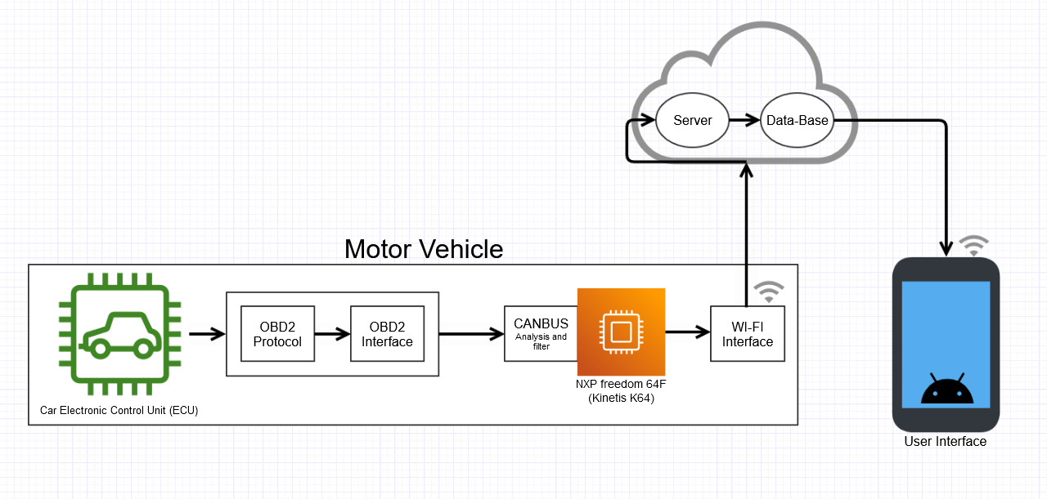**Architecture Design:**

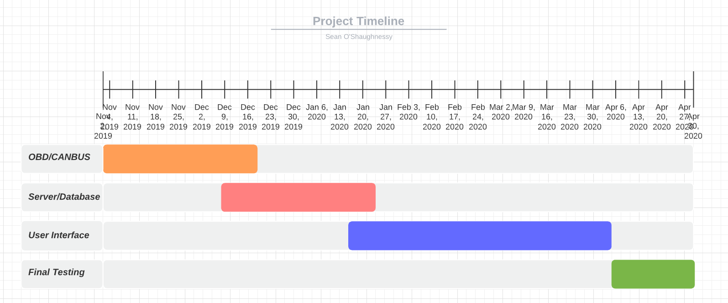**Timeline for deliveries:**

**January 11th, 2021**

**Demonstration**

**Software Programming Language to be used:**

The software language that I will be using to program the NXP freedom 64F is C.

To code the user interface, I will be using Java as the coding language.

My SQL will be used for the database.

**Hardware Components:**

The hardware components of my project are as follows:

* NXP Freedom 64F
* ODB Plug
* Multiple Protocol OBD Ecu Simulator
* Wi-Fi Interface chip
* Mobile Phone (Android)